SUNIL Z

# Mob: +91 9342555166, Email: [z.sunil@yahoo.co.in](mailto:z.sunil@yahoo.co.in)

Seeking assignments in Banking / Financial Institutions as Underwriter for Secured & Unsecured Loan

**SYNOPSIS**

Over 9.5 **years** of experience in Credit assessment, currently serving **HDFC Bank ltd as Area Credit Manager.** Gathered experience in underwriting & driving the process of **two wheeler loan, Loan against gold, Loan against securities, Consumer Loan, Business loans and Personal loans. Financial Analysis especially for superbikes proposals**. Involved in formulating and implementing risk control and credit management strategies, as well as accomplishing the given targets in budgeted parameters. Ability to support and sustain a positive work environment that fosters team performance with relationship management skills. Proven ability of achieving Service Delivery/ Process Targets.

**CAREER SUMMARY**

|  |  |  |  |  |
| --- | --- | --- | --- | --- |
| **PERIOD** | **ORGANIZATION** | **CROLE** | **PRODUCT HANDLED** | **LOCATIONS WORKED** |
| 1st July 2016 Till Date | HDFC Bank | Area Credit Manager | Personal Loan , Business Loan | Emerging Market. Karnataka & Prime channel Bangalore. |
| 1st Sep 2013 TO 31st May 2016 | HDFC Bank | Sr Credit Manager | Personal Loan , Business Loan & Consumer loan . | Bangalore |
| May 2008 To 1st Sep 2013 | HDFC Bank | Credit Manager | Two wheeler Loans, Gold Loans, Loan Against securities, life style product loans & Loan against securities. | Bangalore & rest of Karnataka |
| 1st Sep 2006 TO May 2008 | Centurion bank of Punjab | Credit Manager | Two wheeler Loan & Small ticket PL | Bangalore & Mysore |
| 1th Sep 2005 TO 31th Aug 2006 | Centurion Bank of punjab (Team Lease) | Credit Officer | Two wheeler loan & STPL | Bangalore |
| Feb 2005 TO Aug 2005 | Citi finanacials consumer finance ltd | Out sourced Credit Executive | Auto Loan ,Personal Loan & Two wheeler Loan | Bangalore |

**PERSONAL VITAE**

**Date of Birth :** 28th Nov 1980

**Father’s Name** **:** Zacharias

**Marital Status :** Married

**Address :** No 4 12th main 3rd cross K P Agrahara Bangalore 560023.

**Languages Known :** English, Hindi, Kannada, Tamil, Telugu & bit of Malayalam.

**Hobbies :** Listening Music & Gaming.

References : will be provided on request

**ACADEMIA**

**EDUCATIONAL DETAILS**

QUALIFICATION : B com

: MBA in finance in Anamalai University.

**CERTIFICATIONS: -**

**NPTEL Online Certification from (IIT- Madras) On Python for Data Science.**

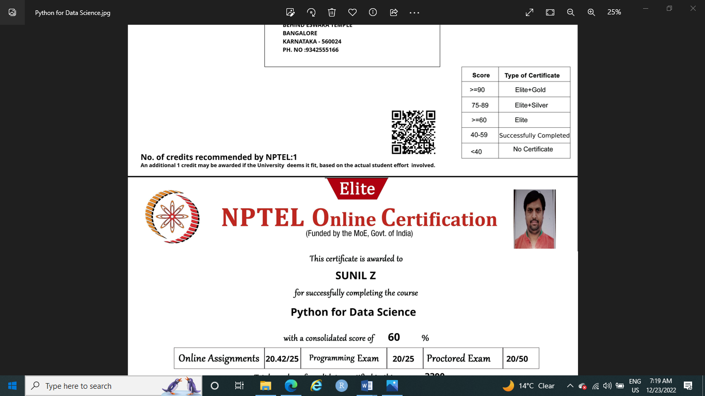

**NPTEL Online Certification from (IIT- Kharagpur) On Machine Learning.**

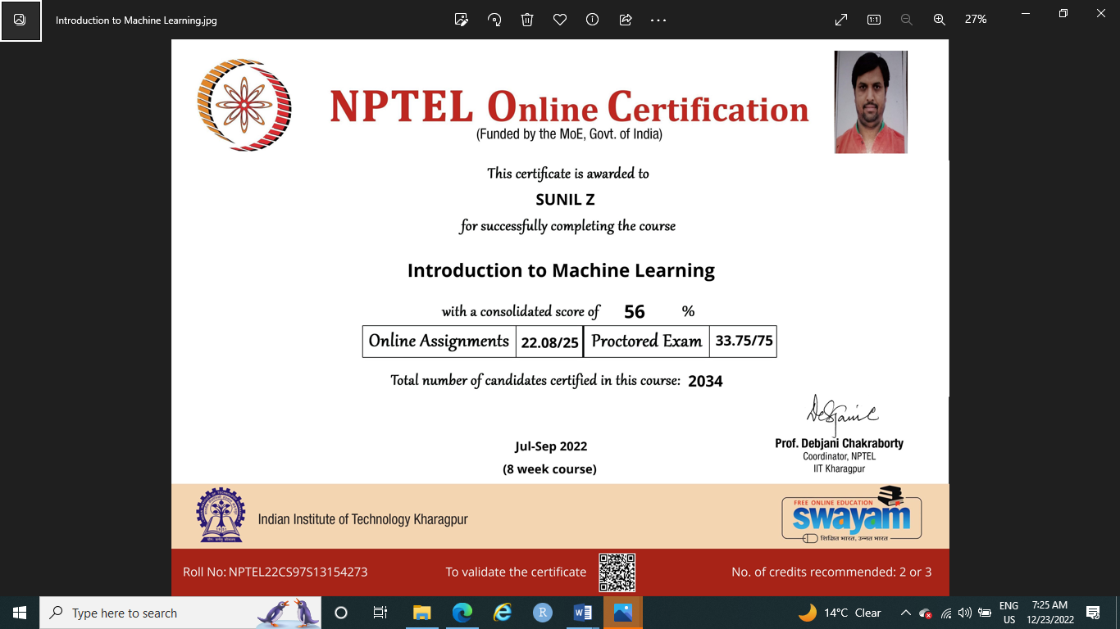

***Assignments completed*** –

* Automation on allocation of files to the credit manager with cutting down 90% of manual intervention and improve the credit manager productivity on daily basis.
* Successfully created Kaizen (OVM) MIS through power query platform which help all the regional supervisor to monitor the micro level parameters such as (daily productivity, Approval rate, RAL, AAL, Pending %, Tat, FTAR & FTDR) daily mis, which are the basic parameters of the credit manager.
* Was leading ACMs team on a study conducted on customer spending pattern analysis done and outcome was in turn implemented as policy on Payday loans & FOIR Score card.

**CAREER PRECISE**

Currently with **HDFC Bank Ltd** from **Sep’13** Under unsecured vertical**.** Designated as **Area Credit Manager**- Handling Bangalore prime market and Emerging market of Karnataka.

**Product: Personal Loan, Business Loan, Consumer Loan, Loan Against securities & Life Style product Loans.**

**Roles & Responsibilities:**

* Managing credit underwriting of all the five products.
* Managing 100+ FTE’s full time which includes training and reviving their performance time to time. Few of them have been elevated as an area manager with in and out side the organisation.
* Appraising credit proposals & judging appropriateness of relevant documents for risk mitigation before sanctioning / disbursing the credit, ensuring compliance with organisational credit policies.
* Performing the functions of assessing creditworthiness of customers and taking adequate steps to ensure receipt of payments.
* Managing the vendor to deliver the best services with respect their SLA.
* Monitoring the vendor performance share the observation month basis while review.
* Maintaining the E2E TAT at all levels in terms of servicing to channels and customers.
* Preparing monthly performance report on the channel / DSA share with them while joint visits done by the business team.
* Fortnightly reviewing soft reject cases & share the observation to RCH.
* Building the book size with a healthy portfolio & regularly monitoring the delinquencies of our channels reporting the same to RCM & RCH.
* Monthly monitoring the EMR %( Earlier mortality rate) & closely working with other function in resolving the same.
* Regular monitoring of NON Starter of the location & reviewing the same in regular intervals.
* Conducting the PFI for high value cases and analysing the authentication of the documents produced by the Customers.
* Responsible for PDP process under consumer loan & achieving the deserved tat of 45min of E2E.
* Ensuring nil Non-compliance on our Internal & External ISO Audits for the location.
* Ensuring the team meeting the productivity
* Responsible for building, mentoring & training Hub team
* Interacting with Branches about their sourcing and delivering feedback about sourcing.
* Funding a right customer with a right amount for which credit is meant.

**Notable Attainments:**

* **Under my supervison the attrition less than 2 % which is best among the peer team members.**
* **Have been declare as champion for the Geo tagging process for our region**
* **By taking the responsiblity our region had reported No 1 in pan India for 6 mnts.**
* **Key inputs shared by me was launched as a Policy where the current delinquance is less 0.21% under this program for last 12 mnts.**
* **Was First to Start PDP procès Under Consumer Durable Loan**
* **Was assigned as champion for CD Loan and Loan Agains Securities**
* **Was first among the team in respect to tat performance.**
* **Was First to enroll 4 cpv vendor in a month.**
* **Was an FPR for the external vendor audit recently conducted found nil exception in external audit.**
* **Was awareded 3rd time as Silver star award in 2015 Oct with as cash price of 5000/- for best portfolio & PAR scoring.**
* **Have been assigned as an FPR for new project called LOS Neo which is about launch in Apr 19.**
* **I have been assigned as an FPR to enable the green channel process which is a key initiative of MD.**

**May’08 - Sep ‘13** worked with **HDFC Bank Ltd.** Designated as **Credit Manager**

**Product: Two wheeler Loan , Gold Loan , Loan against securities & Life Style product Loans.**

**Roles& Responsibilities**

* Approvals of deviation as per policy
* Credit assessment of large ticket size deals of super bikes.
* Enforce of the company credit policy at branch level
* Managing Contact point verification Agencies and Credit Team in branches
* Review and approval loans as per policy
* Responsible for effective work distribution and data reporting which are critical to quality (CTQ)
* Leading training and motivating workforce to achieve organizational goals.
* Analyze and review the portfolio performance to understand the current trend.
* Ensuring the teams productivity
* Regularly monitoring the portfolio behaviour of product which respect to its classification.
* Monthly monitoring the EMR %( Earlier mortality rate) & closely working with other function in resolving the same.
* Regular monitoring of NON Starter of the location & reviewing the same in regular intervals.
* Monthly review done on the PDD collection channel wise & high highlighting the grey areas the business team.
* Deferral / Book & Wait approvals on invoice & Insurance being reviewed & analysing the pendency channel wise & proposing for further extension to the channels is eligible.
* Customize loan programs tailored to meet the financials needs of individual clients. Review credit reports, analyze income statements and perform underwriting of income versus debt and combined asset worth for superbike proposals.
* Enrolment of Umbrella assayers to perform assaying activity at our gold loan branches.
* Ensuring the assayer well trained according to the banks requirements on the process.
* Conducting the seeding activity through our cross functions to have control over the UV’s sub assayers.
* Timely rotation activity of the entire sub assayer from their placed branches.
* Ensuring the SLA of 2Hr on any request placed at branches on 2nd valuations.
* Regular monitoring of the UVs performance on valuations basis cartage given by the sub assayers
* Surprise check on sub assayer on the valuation equipments (acid, touch stone & lime water test) at the branches.
* Engaging the vendors to participate actively in auction conducted on delinquent cases.
* Assisting the business team on swarnotsava activity with the help our UV’s.
* Managing external vendors like the field investigation agency and UVs for timely execution of outsourced tasks in order to ensure that the turns around standards are met.
* Monthly Training to Credit, Sales, DSAs & DSTs for maintaining quality of the files in processing. Periodical new processes roll out meeting with Sales & Credit Team.
* Monitoring the portfolio and analyzing subjective decisions
* Field Visits done on delinquent customers & the feedbacks are given to collections as well as Risk team.
* Internal File audits, Field audits & completeness audits done for all locations to ensure the policy norms are adhered.

**Notable Attainments:**

* **Was assigned as champion for ISO process certification. 2008**
* **Was First to enroll UVs at the location 2009**
* **Was assigned as champion to start imaging process for South -2 location (AP & Kar)for all the products(TW, PL & AL)**
* **Was the winner on Imaging conteste conducted for pan india with gift coupon worth 10K.**
* **Was awarded as Silver star award in 2010 with as cash price of 5000/- for best portfiloe as PAR scoring.**
* **Was nominâted as champion for implémentation of Imaging process at 36 branches including upcountry branches such as mangalore , Mysore & Hubli for all products.**
* **Was awareded 2nd time as Silver star award in 2013 with as cash price of 5000/- for best portfolio as PAR scoring.**
* **Was the running up on pan india contest for tier 1 team with Handling of 3500 cases for 60 days period with a cash prise of 3000/-.**

**Sep’06- May ’08** worked with **Centurion bank of Punjab**, **–** Designated as **Credit Manager**

**Product: Two wheeler Loan & STPL(Small ticket personal loans).**

**Roles& Responsibilities**

* Meet customers prior to credit approval
* Contact point verification and review
* To analyze Credit worthiness of the borrower from credit report.
* To raise the conditions if the policy guidelines are not met in the file.
* Enforce of the company credit policy at branch level
* Approvals of deviation as appear policy
* Review of portfolio with respect to delinquency, fraud and losses of the port folio
* Ensure monthly MIS pertaining to approval and declines relating to TW & PL. And also focus on the E2E TAT.

**Feb ’05 – 31st Aug ’06** worked as an out sourced employee for Citi fianancials & Centurion bank of Punjab **–** Designated as **Credit executive.**

**Product: Auto loan, Two wheeler Loan & STPL(Small ticket personal loans).**

**Roles& Responsibilities**

* Direct monitoring of Field Investigation Agencies, in house TVR team & CPA team.
* Training the CPA team on process & parameters, soft skills to handle customers with care during verification.
* Preparing MIS reports vis-à-vis Credit MIS, Reject MIS and Login MIS.
* Meeting the Turn around times with respect to Field Verification, Tele verification.
* Checking out de dupe for 100% logins.
* Processing the two wheeler applications, taking the final approvals from required levels.
* Screening of all the documents for correctness at predisbursal stage

Date: (Sunil Z)

Place: